Name – Shreya Panda PRN – 25070122181 CSE B3
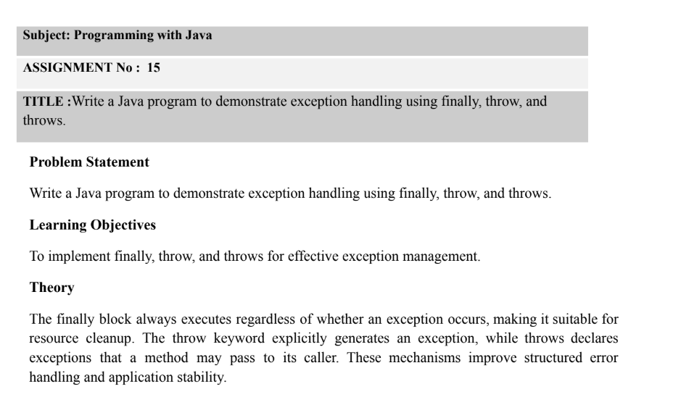
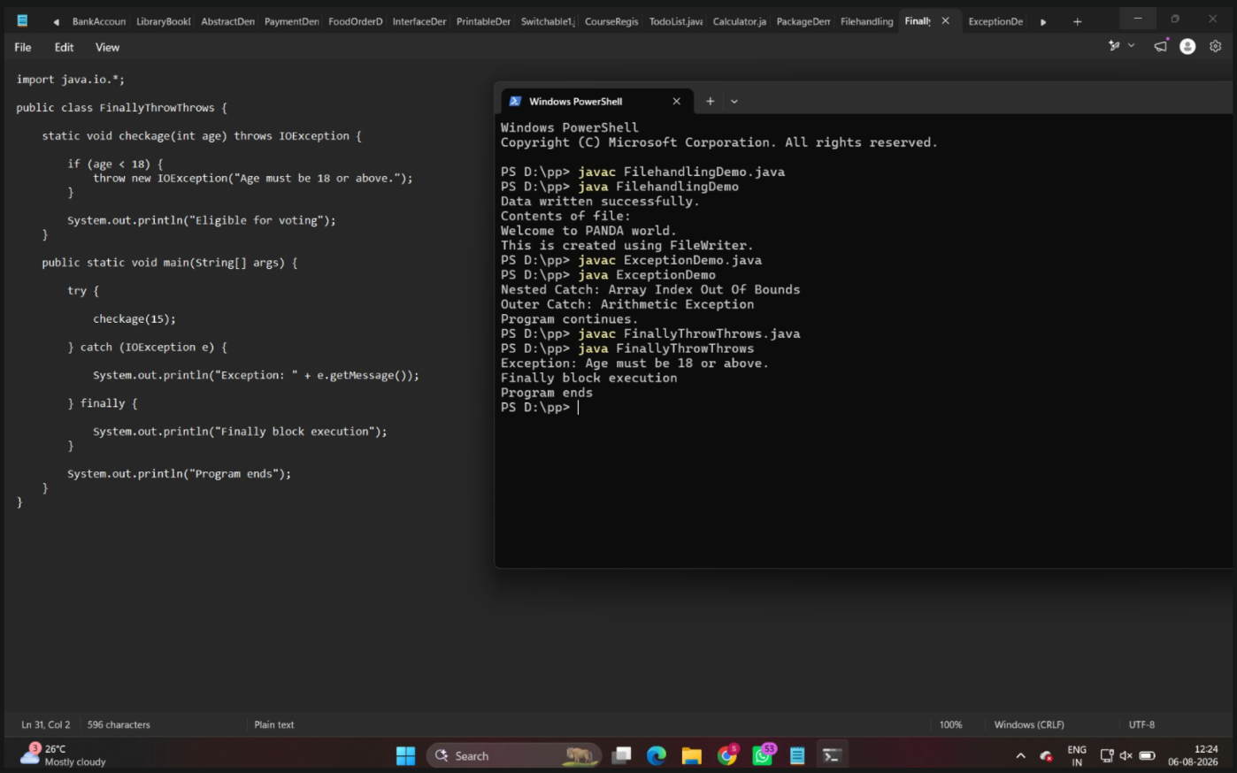
Outcome
Successfully implemented exception handling in Java using the finally, throw, and throws keywords. The program demonstrates how exceptions can be explicitly generated, declared, and handled while ensuring that the finally block executes for cleanup.
Exercise-
1. Create a Login program that throws an exception for invalid password and uses finally block.
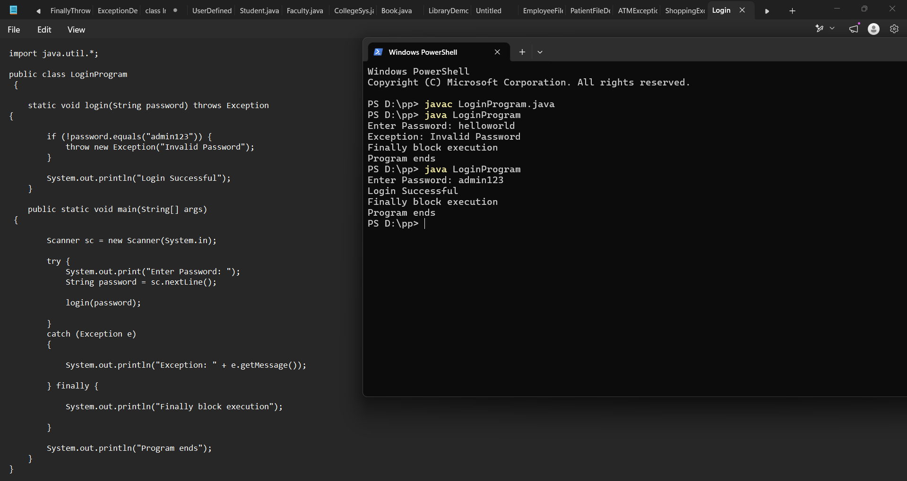
2. Create an ATM PIN Verification program that throws an exception for an invalid PIN entered by theuser and uses a finally block to display a message indicating that the verification process has completed.
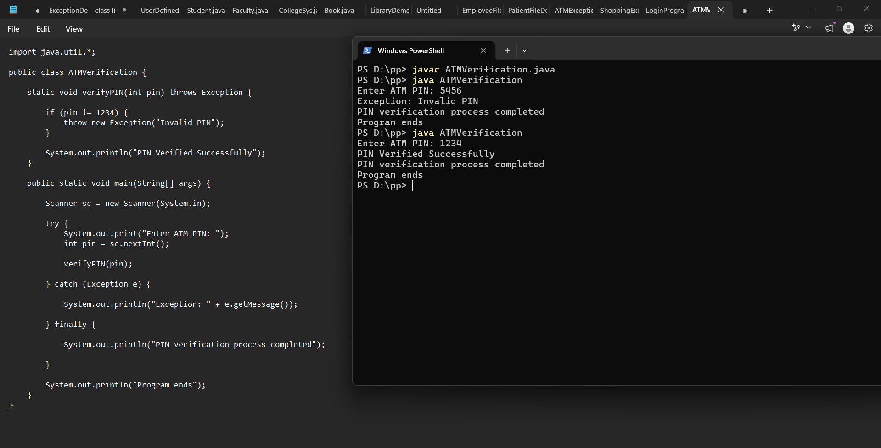

Conclusion
The experiment helped in understanding the use of finally, throw, and throws in Java exception handling. These mechanisms make programs more reliable by managing runtime errors effectively and maintaining proper program flow.

